Why Our Teens Need Life Skills Training Now More Than Ever
As parents, we worry when we see our teenagers stressed, anxious, or lost. Right now in 2026, more than half our Indian teens feel overwhelmed by exams, social media, and life pressures. Good marks matter, but they're not enough. Life skills help our kids feel strong inside, make good choices, and build happy relationships. Let me explain why this matters so much today—and what we can do.
Today's Teens Face Tougher Challenges
Our kids grow up in a different world than we did:
- Social media pressure: 7 hours daily comparing themselves to "perfect" lives online
- Academic Arms Race: In India, competitive exams like JEE/NEET create intense pressure, with 80% of students reporting stress-related health issues.
- Comparison Culture: Social media algorithms amplify feelings of inadequacy, perfectionism, and isolation.
- Delayed Adulthood: Extended adolescence means teens reach 20+ without basic skills like financial literacy or emotional regulation.
- Unlike past generations who learned through trial-and-error, today's teens lack unstructured playtime and real-world practice.
- Life Skills vs Academic Skills: The Critical Difference
Academic Skills | Life Skills
Memorising facts, scoring marks | Emotional regulation under stress
Passing exams | Decision-making in uncertainty
Subject knowledge | Communication and relationship-building
Short-term success | Long-term resilience and happiness

What Are These Life Skills?
What Life Skills Really Are
Life skills equip teens to thrive beyond textbooks:
- Emotional Regulation: Managing anger, anxiety, disappointment
- Communication: Assertive speaking, active listening, boundary-setting
- Decision-Making: Weighing options, accepting consequences
- Financial Literacy: Budgeting, saving, understanding money
- Social Skills: Reading social cues, building healthy friendships
- Self-Care: Sleep, nutrition, stress management
- Digital Literacy: Safe online behaviour, critical thinking about content
The Science Behind Life Skills: Proven Results
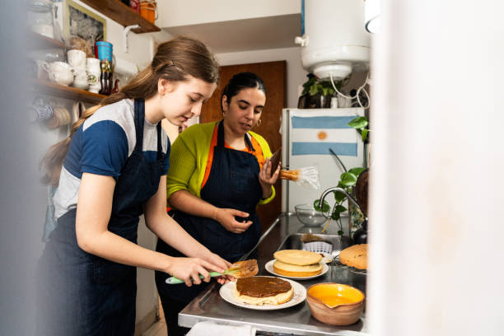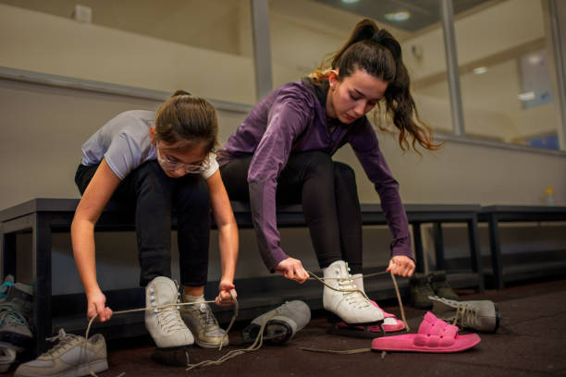
Research validates life skills training:
- Harvard's Grant Study (75+ years): Relationship skills predict happiness more than IQ or wealth.
- WHO 2025 Report: Teens with emotional regulation skills show 40% lower anxiety rates.
- Stanford Study: Social-emotional learning improves academic performance by 11 percentile points.
Science Proves Life Skills Work
Studies show these skills change lives:
- Teens who learn feeling control have 40% less anxiety
- Social skills boost school marks by 11%
- Life skills cut suicide thoughts by 35% (Indian study)
- Best predictor of adult happiness = relationship skills, not IQ
Real Kids, Real Stories
Rohan (16), no life skills: Failed JEE mock test → panic attack → locked in room → blamed parents → dropped marks further.
Priya (16), with life skills: Failed mock test → breathed deeply → talked to mom → made new study plan → scored better + felt confident.
Aarav vs Sneha (friend fight):
- Aarav: Fought with best friend → posted mean things online → lost all friends
- Sneha: Said "I feel hurt when..." → found solution → friendship stronger
Why Parents Must Act Now:
Today's parenting challenges amplify the need:
- Delayed Adolescence: Teens reach 25 without basic independence.
- Academic Obsession: Indian families prioritise marks over mental health (92% of parents focus on academics first).
- Digital Parenting Gap: Parents struggle to model healthy tech use.
- Societal Pressure: "Success = High Salary" narrative leaves emotional skills neglected.
Dr Aruna Broota (Psychologist): "Teens with life skills handle failure 3x better than academically brilliant peers without them."
5 Practical Next Steps for Busy Parents
- Daily Micro-Practices (5 mins): Teach breathing exercises during dinner table talks.
- Role Modelling: Show healthy conflict resolution and budgeting in front of kids.
Family Meetings: Weekly 15-min check-ins for sharing wins/challenges.
- Enrol in Workshops: Look for local/online life skills programs (CBSE recommends 40 hours/year).
- Tech Boundaries: Family screen-time contracts + digital literacy discussions.
Call to Action: Empower Your Teen Today

#LifeSkillsForTeens #TeenCounseling #EmotionalRegulation #CommunicationSkills #ConflictResolution #SelfAwareness #TeenDevelopment #YouthEmpowerment #LifeSkillsTraining #FutureReadyTeens #ParentingTeens #MentalWellbeing #GrowthMindset #characterbuilding #TeenSuccess#futureleaders#Youthempowerment#Resilience#Communication Skills#Socialskills#

Manju George
Counselling Psychologist &Life Skills Trainer
Shalom-Therapy

